**\*\*\* START OF IN CLASS OPEN BOOK SECTION\*\*\***

|  |  |  |  |
| --- | --- | --- | --- |
| Name: | ___________________________________________________ | | Date: *___________* |
| **Total Time:** | | ***50*** *minutes* |  | |
| **Equipment:** | | *The Take-Home section of this investigation, INB Book, text book, Scientific Calculator* | | |
| ***Full working out must be shown to get full marks.***  ***Attempt all questions*** | | | |

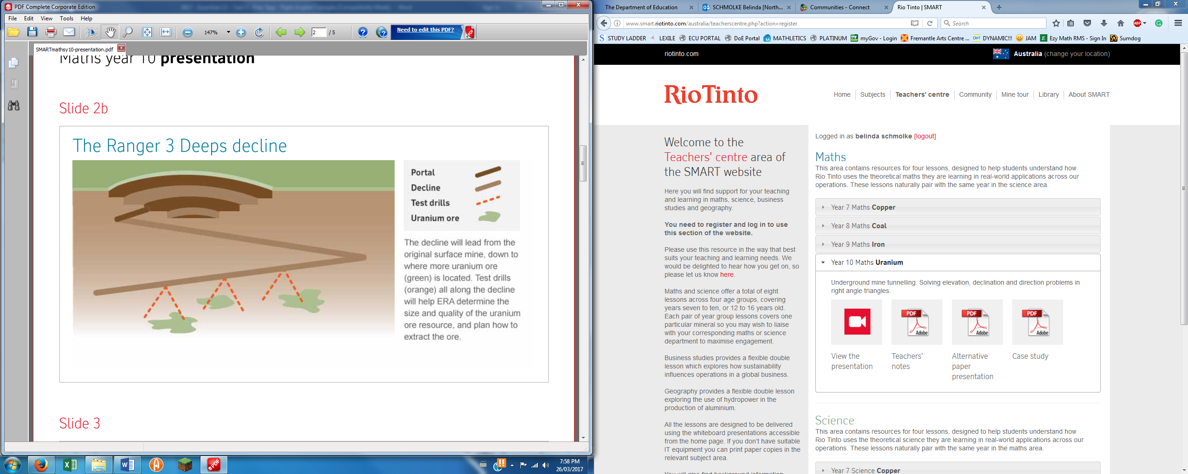

Figure 1 The Ranger 3 Deeps Decline

1. Figure 1 shows the proposed tunnels that will be drilled in order to access the uranium containing ore. What would be the impact if the angle of decline of the tunnels were too steep? Give two ideas.

(two marks)

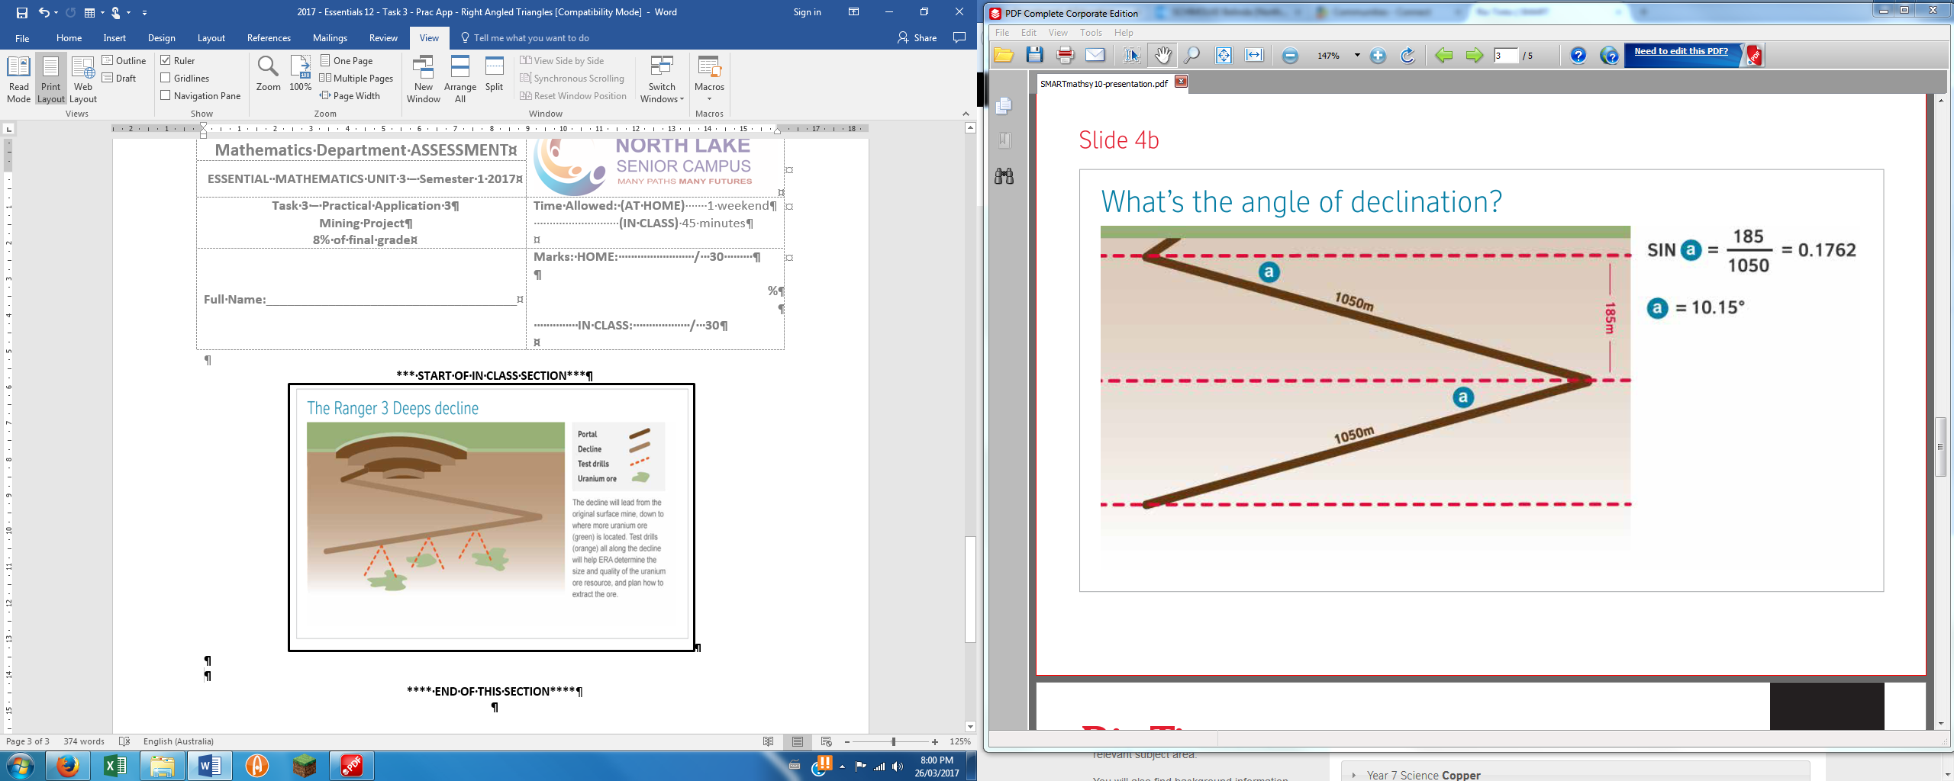

Figure 2 Calculation of the angle of declination

1. Figure 2 shows the method that is used to calculate the angle of declination for two tunnels that are 1050m long which go down 185m each. What would be the new angle of declination if the tunnels were each100m longer?

(three marks)

1. What would be the new angle of declination if the tunnels were 100m shorter?

(three marks)

1. The maximum angle of declination that is a) safe for the trucks, and b) economical for the trucks is 10.30°. What length do the two tunnels each need to be in order for this condition to be met?

(four marks)

750m

Mine Entrance



Tunnel Collapse

9.5o

Vertical escape shaft

1. The tunnel that declines at 9.5o has collapsed, trapping the miners inside. The rescue team decide to drill a vertical escape shaft from a position 750 m horizontally from the mine entrance. How deep does the rescue shaft need to be to meet the declining tunnel? HINT: Draw a diagram to match this situation. Answer correct to 2 decimal place. (three marks)

1. If the tunnel collapse is 690m down the decline tunnel at 9.5o how far horizontally from the mine entrance is the actual tunnel collapse? (three marks)
2. By drilling the vertical escape shaft and additional 50 m horizontally from the tunnel the rescue team have to drill quite a bit deeper. Why do you think the rescue team choose to drill this extra depth and distance from the mine entrance? (two marks)

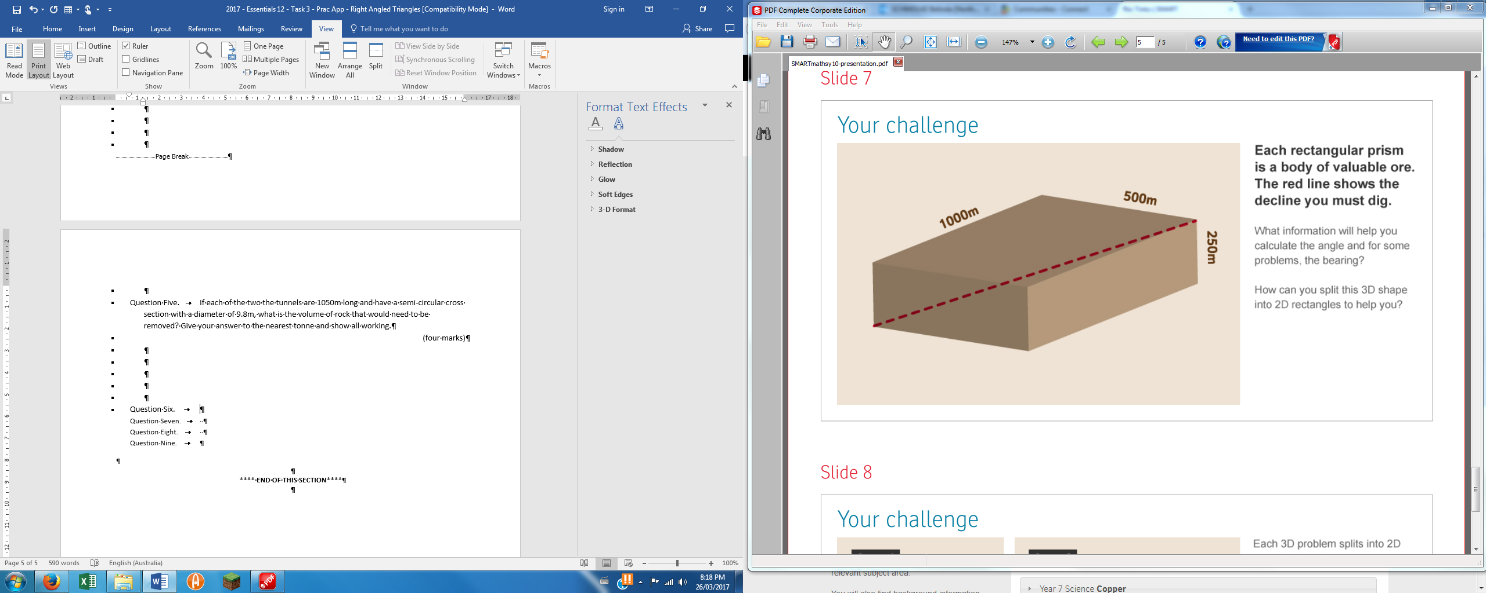

Figure 3 Body of Valuable Ore

Figure 3 shows an approximation of a body of valuable ore.

1. Calculate the angle of declination shown as the dotted line in Figure 3.

(five marks)

**\*\*\*\* END OF THIS SECTION\*\*\*\***